**2**

**0**

**1**

**0**

*ANNUAL*

*REPORT*



*What’s*

*Inside*

*Repair & Maintenance*

*Accomplishments*

*Picture Galleries*

*ITCSO Profile*

*Information Systems*

*IT Resources*

Republic of the Philippines

City of San Carlos

Province of Negros Occidental

City Administrator’s Office

**Information Technology and Computer Services Office**

February 25, 2011

**HON. GERARDO P. VALMAYOR, JR.**

City Mayor

San Carlos City, Neg. Occ.

Sir:

Respectfully forwarded to your office the 2010 Annual Report of Information Technology and Computer Services Office (ITCSO).

Request acknowledge receipt.

Respectfully yours,

**JOSEPH A. BINGHAY**

Information Technology Officer II

Noted by:

**FRANCISCO B. TOLCIDAS, CPA**

City Administrator

cc: CMO

Administrator’s Office

Vice-Mayor’s Office

Chairman, SP Committee on Finance

Information Officer

File

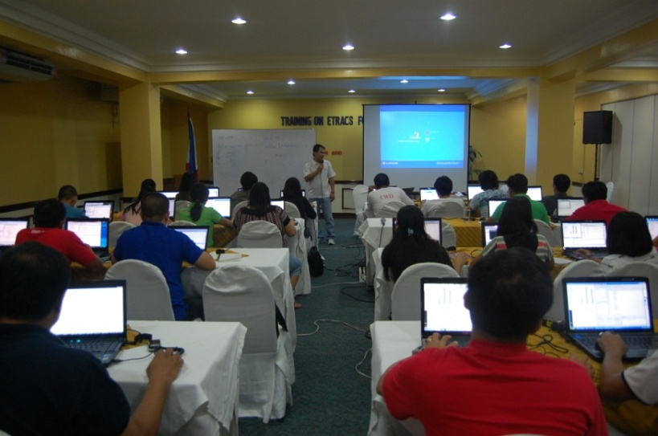

* It coordinates with the user departments, IT vendors, non-government entities, other government agencies and serve as the key unit regarding the computerization program of the City.
* It help defines and specifies the computer hardware and software requirements of user departments, and facilitates, control and monitor the acquisition and distribution of computer software, hardware and other information systems components in the LGU.
* Design, maintain and control the central database system (DBS) of the LGU ensuring database integrity and security, storage and back-up systems.
* Serve as a key unit in the electronic data processing of geographic resource, fiscal and administrative information as a support system to the various user departments.
* Implement and maintain the full functionality and security of the network and internet-connectivity of the LGU, monitor internet usage, and develop and enhance the City’s website.
* Design and implement in-house applications software development and evaluate out-sourced information systems for the use of the LGU.
* Design and implement training and human resource development and capacity building of LGU employees and constituents regarding computing skills and knowledge.
* Provide repair and maintenance services of computer software and hardware to user departments.

***The INFORMATION TECHNOLOGY AND COMPUTER SERVICES OFFICE under the CITY ADMINISTRATOR’S OFFICE of the City of San Carlos shall serve as the planning and implementing unit for information and technology-related programs and projects of the Local*** *Government Unit of the City of San* ***Carlos, specifically:***

*OUR FUNCTIONS*

*PROFILE*

Vision Statement

Achieve full automation in all Local Government Offices of the City of San Carlos to capacitate linkage, thus realizing tenets of accountability, transparency, efficiency and effective local governance.

Mission Statement

To establish an effective and functional Information Technology and Computer Services Office (ITCSO) to support the San Carlos City Local Government’s objectives in improving the life of its constituents.

Goals

* To enhance LGU capability by means of appropriate Information Technology resources.
* To maximize the use of Information Technology and such applications to enhance LGU transparency, accountability and internal control system in its administrative and fiscal affairs, and resource management.
* To assist LGU thru telecommunication facilities to forge closer ties with its people, form community development partnerships with the private sector and non-government organizations (NGO’s) and to establish linkage to LGUs, the Private Sector and those connected to the World Wide Web.

Strategies

* Link the departments of the City Government of San Carlos as far as Information Technology is concerned.
* Improve planning-related initiatives in line with the delivery of basic services to the general public.

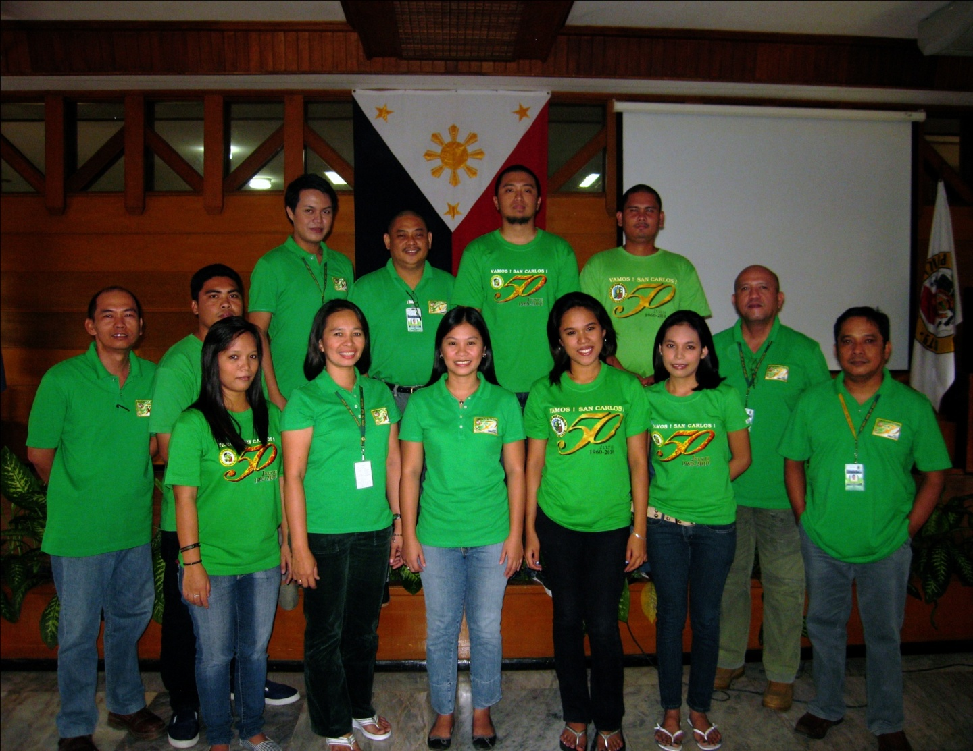

|  |  |  |
| --- | --- | --- |
| IT POSITIONS | **SALARY GRADE** | **NO. OF**  **IT PERSONNEL** |
| **Information Technology Officer II** | **SG 22** | **1** |
| **Information Systems Analyst III** | **SG 19** | **1** |
| **Computer Maintenance Technologist II** | **SG 15** | **1** |
| **Information Systems Analyst I** | **SG12** | **1** |
| **Computer Operator III** | **SG 12** | **1** |
| **Computer Operator I** | **SG 7** | **1** |
| **Clerk III** | **SG6** | **1** |
| **Governmental Casual** | **-** | **6** |
| **TOTAL** |  | **13** |

2

Summary of **Staffing & Manpower**

WEB DEVELOPMENT AND MAINTENANCE

HARDWARE AND SOFTWARE MAINTENANCE

APPLICATION DEVELOPMENT AND OPERATIONS

Information Technology Officer II

SG 22

*Joseph A. Binghay*

Information Systems Analyst I

SG 12

*Sharon S. Catedral*

Computer Maintenance Technologist II

SG 15

*Vicente Roland R. Montebon*

Computer Operator III

SG 12

*Renato G. Buenaobra*

Government Casual

*Exar A. Sumbal*

*John D. Carbelledo*

Computer Operator I

SG 7

*Felix Michael F. Oberes*

Government Casual

*Andrelou A. Ecoy*

*Edward Aldie V. Apuhin*

Information Systems Analyst III

SG 19

*Rommel B. dela Victoria*

Government Casual

*Leah Marie O. Auhocco*

*Helen Grace B. Gonzaga*

Clerk III

SG 6

*Mauren L. Talorong*

Organizational **Structure**

3

**SYSTEM ADMINISTRATOR**

* Manages and the city's computer software requirements as well as web development and hardware maintenance.
* Manages the database integrity and security and ensure data storage, back-ups and archiving tasks.
* Evaluates programs to check if conforming to design and specifications.
* Evaluates out-sourced information systems for use of the local government unit.
* Reviews and initials IT related purchase requests (local and national) regarding office computers, accessories and supplies.
* Coordinates directly with the user departments regarding systems project to be developed, maintained and enhanced.
* Analyzes resources utilization and initiates program improvements.
* Monitors the implementation of various information systems of the city.
* Coordinates and assists co-employees in various day-to-day operational functions necessary in maintaining a smooth and continuous processing environment.
* Identifies and analyzes computer capability building and training needs of various user departments.

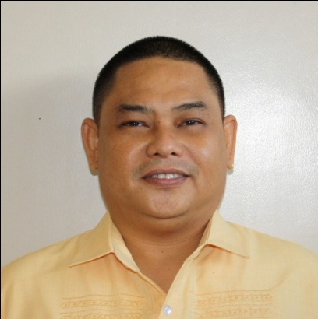

**JOSEPH A. BINGHAY**

INFORMATION TECHNOLOGY OFFICER II

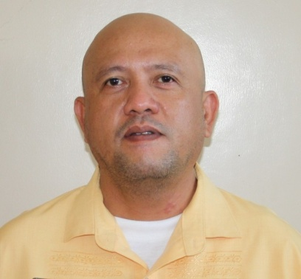

**WEB MASTER**

* Leads the development, deployment and maintenance of the City’s Official Website.
* Handles the uploading of web-page updates and archiving works for past publications of the web-page.
* Maintains the database integrity and security and ensure data storage, back-ups and archiving tasks.
* Assists in the deployment of information systems in the user sites.
* Ensures the full functionality of the application system deployed to the different offices of the city.
* Coordinates and assists co-employees in various day to day operational functions necessary in maintaining a smooth and continuous processing environment.
* Reports to its direct superior the status of system implementation and recommend improvements to the system when required.

**ROMMEL B. DELA VICTORIA**

INFORMATION SYSTEMS ANALYST III

Job Description of **IT Personnel**

4

**LOCAL NETWORK ADMINISTRATOR**

* Plans, organizes, manages and controls the local application network.
* Configures and installs the network, defines capacity, rights and handles relocation and reconfiguration of network setup when required.
* Ensures the full functionality of the network.
* Ensures network connectivity for reliable access of data to the different offices of the city government.
* Conducts preventive maintenance to all government owned personal computers and attached peripherals.
* Supervises and handles in-house repairs of computer hardware and coordinate outsourced repair and maintenance work.
* Coordinates and assists co-employees in various day to day operational functions necessary in maintaining a smooth and continuous processing environment.
* Performs periodic review of the functions performed by the network and evaluates if technical requirement are met.

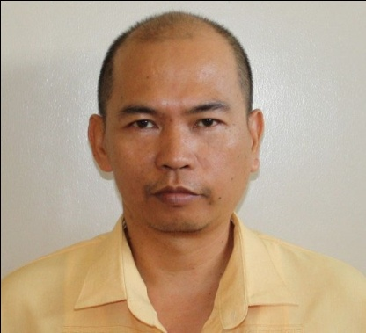

Job Description of **IT Personnel**

**INTERNET NETWORK ADMINISTRATOR**

* Plans, organizes, manages and controls the internet network.
* Configures and installs the network, defines capacity, rights and handles relocation and reconfiguration of network setup when required.
* Ensures the full functionality of the network.
* Ensures network connectivity for reliable access of data to the different offices of the city government.
* Conducts preventive maintenance to all government owned personal computers and attached peripherals.
* Handles in-house repairs of computer hardware and coordinate outsourced repair and maintenance work.
* Coordinates and assists co-employees in various day to day operational functions necessary in maintaining a smooth and continuous processing environment.
* Performs periodic review of the functions performed by the network and evaluates if technical requirement are met.

**VICENTE ROLAND R. MONTEBON**

COMPUTER MAINTENANCE TECHNOLOGIST II

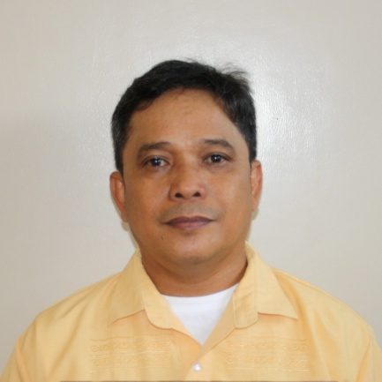

**RENATO G. BUENAOBRA**

COMPUTER OPERATOR III

5

**APPLICATION ADMINISTRATOR**

* Leads the various programming tasks of the software application systems.
* Handles the design and testing of information systems in the user sites.
* Takes charge of the documentation of developed and out-sourced applications systems deployed to the different offices of the LGU.
* Implement deployment of information system in the user site.
* Ensures the full functionality of the application system being deployed to the different offices of the LGU.
* Coordinates and assists co-employees in various day to day operational functions necessary in maintaining a smooth and continuous processing environment.
* Reports to its direct superior the status of system implementation and recommends improvements to the system when required.

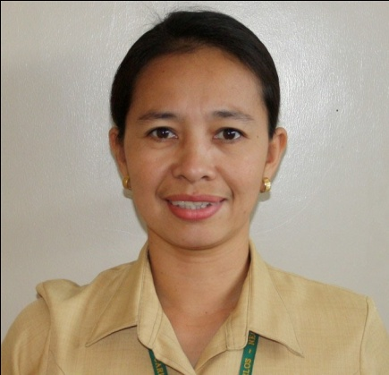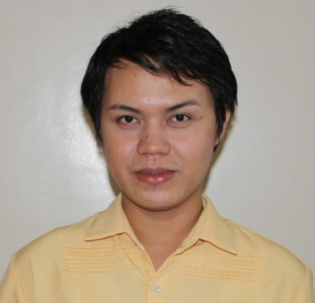

**APPLICATION DOCUMENTOR**

* Assists the programmer in various programming tasks of the software application systems.
* Assists the programmer in the design and testing of information systems in the user sites.
* Assists in the deployment of various information systems in the user site.
* Takes charge of the presentation materials both video and multi-media as may be required by the different offices of the LGU.
* Ensures the full functionality of the application system being deployed to the different offices of the LGU.
* Coordinates and assists co-employees in various day to day operational functions necessary in maintaining a smooth and continuous processing environment.
* Reports to its direct superior the status of system implementation and recommends improvements to the system when required.

**FELIX MICHAEL F. OBERES**

COMPUTER OPERATOR I

**SHARON S. CATEDRAL**

INFORMATION SYSTEMS ANALYST I

Job Description of **IT Personnel**

6

**ARCHIVING-IN-CHARGE**

* Assists the programmer in various programming tasks of the software application systems.
* Assists the programmer in the design and testing of information systems in the user sites.
* Assists in the deployment of various information systems in the user site.
* Takes charge of the various clerical and archiving tasks of the office.
* Ensures the full functionality of the application system being deployed to the different offices of the LGU.
* Coordinates and assists co-employees in various day to day operational functions necessary in maintaining a smooth and continuous processing environment.
* Reports to its direct superior the status of system implementation and recommends improvements to the system when required.

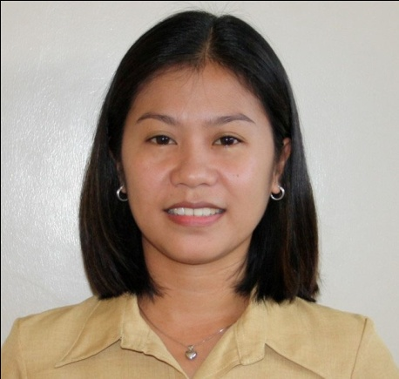

**MAUREEN L. TALORONG**

CLERK III



**WEB DEVELOPMENT SUPPORT**

* Assists in the web-development tasks of the LGU.
* Assists in the uploading of web-page updates and archiving work for past publications of the web-page
* Coordinates and assists co-employees in various day to day operational functions necessary in maintaining a smooth and continuous processing environment.
* Reports to its direct superior the status of website deployment and recommends improvements when required.

**LEAH MARIE O. AUHOCCO**

JOB-ORDER EMPLOYEE



**HELEN GRACE B. GONZAGA**

JOB-ORDER EMPLOYEE

Job Description of **IT Personnel**

7

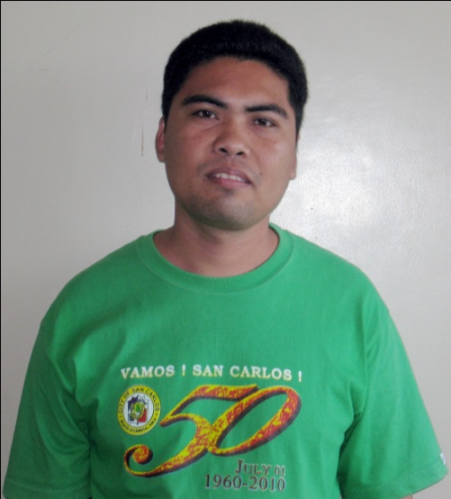

**NETWORK TECHNICAL SUPPORT**

* Assists the Network Administrators in planning, organizing, managing and controlling both the local and internet networks.
* Coordinates and assists co-employees in various day to day operational functions necessary in maintaining a smooth and continuous processing environment.
* Reports to its direct superior the status of the local area network and recommends improvements when required.
* Assists in the in-house repairs of computer hardware and maintenance work.

**EXAR A. SUMBAL**

JOB-ORDER EMPLOYEE

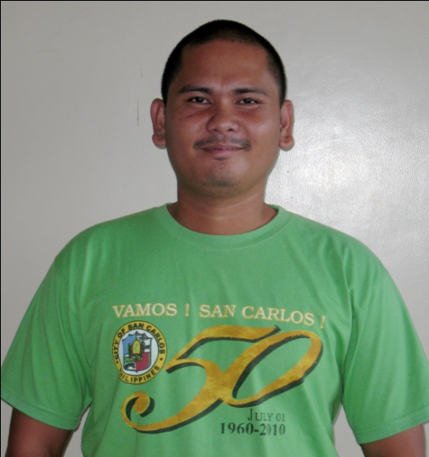

**JOHN D. CARBELLEDO**

JOB-ORDER EMPLOYEE

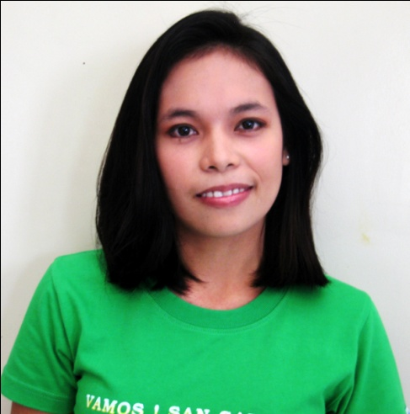

**SYSTEM DEVELOPMENT SUPPORT**

* Assists in the various programming tasks of the software application systems.
* Assists in the design and testing of information systems in the user sites.
* Assists in the implementation of the information systems in the user sites.
* Coordinates and assists co-employees in various day to day operational functions necessary in maintaining a smooth and continuous processing environment.
* Reports to its direct superior the status of system implementation and recommends improvements to the system when required.

**ANDRELOU A. ECOY**

JOB-ORDER EMPLOYEE

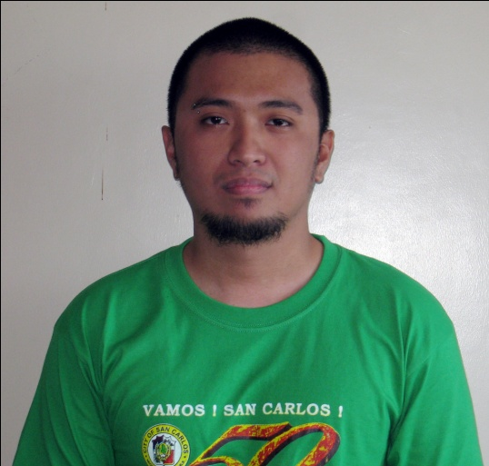

**EDWARD ALDIE V. APUHIN**

JOB-ORDER EMPLOYEE

Job Description of **IT Personnel**

8

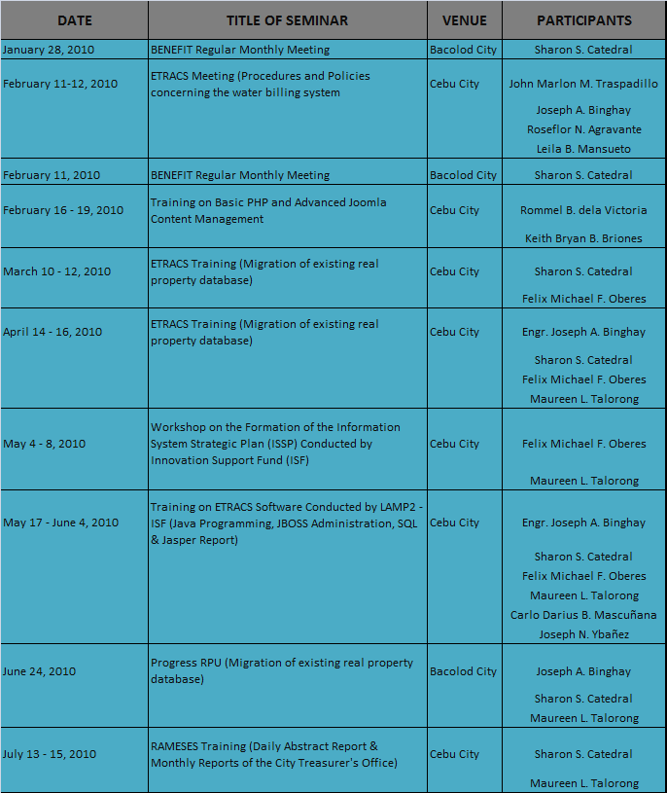

Meetings/Trainings & Seminars **Attended**

9

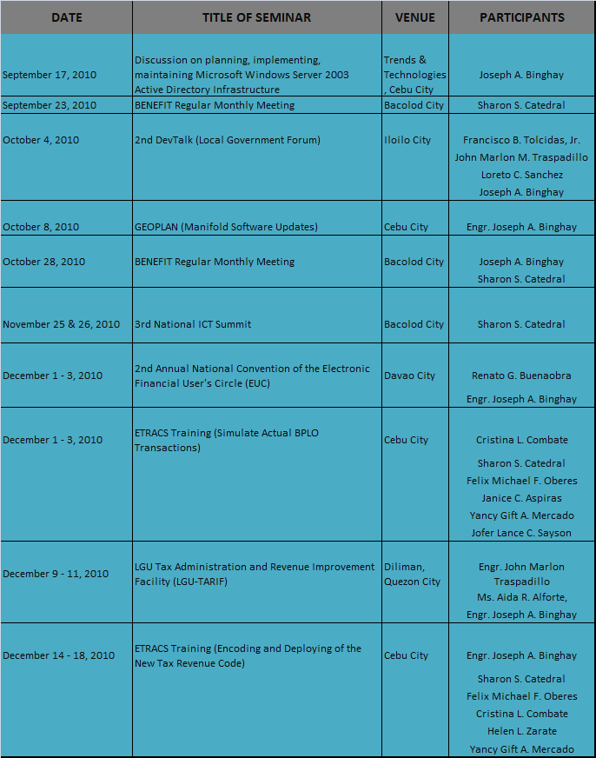

Meetings/Trainings & Seminars **Attended**

10

INFORMATION SYSTEMS & **IT RESOURCES**

|  |  |  |
| --- | --- | --- |
| **INFORMATION SYSTEM** | **OFFICE DEPLOYED** | **STATUS** |
| Enhanced Tax Revenue Assessment and Collection System (eTRACS)   * Tax Collection Module | City Treasurer’s Office | Operational |
| * Real Property Tax Assessment Module | City Assessor’s Office | Database Build-Up |
| * Business Permit and Licensing Module | Business Permit and Licensing Office | Operational |
| * Community Tax Certificate Module | City Treasurer’s Office | Operational |
| * Building Official Module | City Engineering Department | For Implementation |
| * Water Billing Module | City Waterworks Department | For Implementation |
| * Market Collection Module | Market and Slaughterhouse Department | For Implementation |
| Real Property Tax Collection System (RPTCS) | City Treasurer’s Office | Operational but Outdated |
| Real Property Tax Assessment System (RPTAS) | City Assessor’s Office | Operational but Outdated |
| Geographical Information System (GIS) | City Assessor’s Office | Operational with System Modification |
| Personnel Information System (PIS) | Human Resource and Management Office | Operational with System Modification |
| Time Management System (TMS) | Human Resource and Management Office | Operational |
| Files Archiving System (FAS) | Sangguniang Panlungsod Office | Operational |
| Government Procurement System  (GPS) | General Services Department | Under Study |
| Electronic New Government Accounting System (eNGAS) | Accounting and Internal Audit Services Department | Operational |
| Personnel Payroll System (PPS) | Accounting and Internal Audit Services Department | Under Study |
| Budget Monitoring System (BMS) | City Budget and Management Office | Under Study |
| Police Matters Information System (PMIS) | Philippine National Police | Operational |
| City Hospital Billing and Collection System (CHBCS) | City Hospital Department | Operational with System Modification |
| Barangay Clearance Issuance System (CHBS) | All Barangays | Trial Run-Through |

Information Systems **Deployed**

12

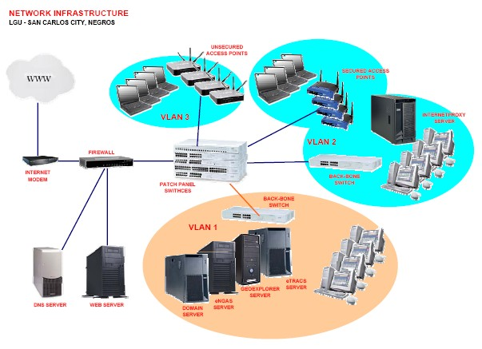

Network **Infrastructure**

13

|  |  |  |
| --- | --- | --- |
| **NAME OF OFFICE/ ORGANIZATIONAL UNITS** | **DESCRIPTION OF THE ICT EQUIPMENT** | **NUMBER OF UNITS** |
| **City Mayor's Office** | Intel Dual Core Notebook Computer | 1 |
| Intel Core 2 Duo Desktop Computer | 1 |
| Intel Dual Core Desktop Computer | 5 |
| Pentium IV Desktop Computer | 1 |
| DeskJet Printer | 5 |
| Dot-Matrix Printer | 3 |
| UPS | 3 |
| AVR | 3 |
| Switch | 1 |
| **Sangguniang Panlungsod Office** | I5 Series Notebook Computer | 13 |
| Pentium IV Notebook Computer | 1 |
| Intel Core 2 Duo Desktop Computer | 1 |
| Intel Dual Core Desktop Computer | 6 |
| Pentium IV Desktop Computer | 3 |
| Pentium III Desktop Computer | 1 |
| DeskJet Printer | 4 |
| Dot-Matrix Printer | 9 |
| Flatbed Scanner | 2 |
| Multi-Media Projector | 1 |
| UPS | 10 |
| AVR | 7 |
| Switch | 1 |
| **Information Technology and Computer Services Office (ITCSO)** | Intel Dual Core Notebook Computer | 3 |
| Intel Celeron Notebook Computer | 1 |
| Pentium IV Notebook Computer | 1 |
| Intel Core 2 Duo Desktop Computer | 1 |
| Intel Dual Core Desktop Computer | 2 |
| Pentium IV Desktop Computer | 6 |
| DeskJet Printer | 1 |
| Flatbed Scanner | 1 |
| Multi-Media Projector | 2 |
| UPS | 9 |
| AVR | 7 |
| Switch | 5 |
| **Accounting & Internal Audit Services Department (AIAS)** | Intel Dual Core Desktop Computer | 13 |
| Pentium IV Desktop Computer | 8 |
| DeskJet Printer | 2 |
| Dot-Matrix Printer | 7 |
| UPS | 15 |
| AVR | 11 |
| Switch | 1 |

Deployment of **IT Equipment**

14

|  |  |  |
| --- | --- | --- |
| **NAME OF OFFICE/ ORGANIZATIONAL UNITS** | **DESCRIPTION OF THE ICT EQUIPMENT** | **NUMBER OF UNITS** |
| **City Engineering Department** | Intel Core 2 Quad Core Desktop Computer | 2 |
| Intel Dual Core Desktop Computer | 8 |
| Intel Celeron Desktop Computer | 1 |
| Pentium IV Desktop Computer | 1 |
| DeskJet Printer | 5 |
| Dot-Matrix Printer | 12 |
| Plotter | 2 |
| UPS | 17 |
| AVR | 17 |
| Switch | 1 |
| **City Planning & Development Coordinator's Office** | Intel Dual Core Desktop Computer | 1 |
| Intel Celeron Desktop Computer | 1 |
| Pentium IV Desktop Computer | 1 |
| DeskJet Printer | 1 |
| Dot-Matrix Printer | 2 |
| UPS | 3 |
| AVR | 3 |
| **City Budget & Management Office** | Intel Celeron Notebook Computer | 1 |
| Intel Dual Core Desktop Computer | 5 |
| Pentium IV Desktop Computer | 5 |
| DeskJet Printer | 7 |
| Dot-Matrix Printer | 1 |
| UPS | 9 |
| AVR | 9 |
| Switch | 1 |
| **City Treasurer's Office** | Intel Dual Core Notebook Computer | 1 |
| Intel Celeron Notebook Computer | 2 |
| Intel Core 2 Duo Desktop Computer | 2 |
| Intel Dual Core Desktop Computer | 13 |
| Intel Celeron Desktop Computer | 1 |
| Pentium IV Desktop Computer | 5 |
| DeskJet Printer | 1 |
| Dot-Matrix Printer | 19 |
| UPS | 22 |
| AVR | 21 |
| Switch | 1 |

Deployment of **IT Equipment**

15

|  |  |  |
| --- | --- | --- |
| **NAME OF OFFICE/ ORGANIZATIONAL UNITS** | **DESCRIPTION OF THE ICT EQUIPMENT** | **NUMBER OF UNITS** |
| **General Services Department** | Intel Celeron Notebook Computer | 1 |
| Intel Core 2 Duo Desktop Computer | 6 |
| Intel Dual Core Desktop Computer | 8 |
| DeskJet Printer | 3 |
| Dot-Matrix Printer | 10 |
| UPS | 12 |
| AVR | 12 |
| Switch | 1 |
| **Department of Social Welfare & Development (DSWD)** | Intel Dual Core Desktop Computer | 2 |
| Pentium IV Desktop Computer | 1 |
| DeskJet Printer | 2 |
| Dot-Matrix Printer | 1 |
| UPS | 3 |
| AVR | 3 |
| **City Assessor's Office** | Intel Dual Core Notebook Computer | 1 |
| Intel Core 2 Duo Desktop Computer | 3 |
| Intel Dual Core Desktop Computer | 3 |
| Intel Celeron Desktop Computer | 1 |
| Pentium IV Desktop Computer | 1 |
| DeskJet Printer | 1 |
| Dot-Matrix Printer | 5 |
| UPS | 9 |
| AVR | 6 |
| Switch | 1 |
| **Office of the Register of Deeds** | Intel Dual Core Desktop Computer | 1 |
| DeskJet Printer | 0 |
| Dot-Matrix Printer | 0 |
| Flatbed Scanner | 0 |
| UPS | 0 |
| AVR | 1 |
| Switch | 1 |
| Deployment of **IT Equipment**  **Commission on Audit** | Intel Dual Core Desktop Computer | 1 |
| Pentium IV Desktop Computer | 1 |
| DeskJet Printer | 2 |
| Dot-Matrix Printer | 2 |
| UPS | 5 |
| AVR | 4 |
| Switch | 1 |

16

|  |  |  |
| --- | --- | --- |
| **NAME OF OFFICE/ ORGANIZATIONAL UNITS** | **DESCRIPTION OF THE ICT EQUIPMENT** | **NUMBER OF UNITS** |
| **Office for Human Resource Management** | Intel Celeron Notebook Computer | 1 |
| Intel Dual Core Desktop Computer | 3 |
| Pentium IV Desktop Computer | 5 |
| DeskJet Printer | 2 |
| Dot-Matrix Printer | 3 |
| UPS | 7 |
| AVR | 8 |
| Switch | 1 |
| **Department of Agrarian Reform** | Intel Core 2 Quad Core Desktop Computer | 1 |
| Pentium IV Desktop Computer | 1 |
| DeskJet Printer | 2 |
| UPS | 2 |
| AVR | 2 |
| Switch | 1 |
| **Department of the Interior & Local Government** | Intel Dual Core Desktop Computer | 1 |
| Intel Celeron Desktop Computer | 2 |
| AMD Desktop Computer | 1 |
| DeskJet Printer | 2 |
| Dot-Matrix Printer | 1 |
| Flatbed Scanner | 0 |
| UPS | 0 |
| AVR | 4 |
| Switch | 1 |
| **Public Employment Services Office (PESO)** | Pentium IV Desktop Computer | 1 |
| AMD Desktop Computer | 1 |
| DeskJet Printer | 0 |
| Dot-Matrix Printer | 1 |
| UPS | 1 |
| AVR | 2 |
| Switch | 1 |
| **Office of the City Agriculturist** | Intel Celeron Notebook Computer | 1 |
| Pentium IV Desktop Computer | 4 |
| Intel Celeron Desktop Computer | 1 |
| DeskJet Printer | 1 |
| Dot-Matrix Printer | 4 |
| Flatbed Scanner | 1 |
| UPS | 4 |
| AVR | 5 |
| Switch | 1 |

Deployment of **IT Equipment**

17

|  |  |  |
| --- | --- | --- |
| **NAME OF OFFICE/ ORGANIZATIONAL UNITS** | **DESCRIPTION OF THE ICT EQUIPMENT** | **NUMBER OF UNITS** |
| **City Legal Office** | Intel Dual Core Desktop Computer | 1 |
| Pentium IV Desktop Computer | 1 |
| DeskJet Printer | 1 |
| Dot-Matrix Printer | 1 |
| Flatbed Scanner | 0 |
| UPS | 2 |
| AVR | 2 |
| **Casual Employment Services Office** | Intel Dual Core Desktop Computer | 1 |
| Pentium IV Desktop Computer | 1 |
| DeskJet Printer | 0 |
| Dot-Matrix Printer | 1 |
| Flatbed Scanner | 0 |
| UPS | 2 |
| AVR | 2 |
| **Office of the City Civil Registrar** | Intel Dual Core Desktop Computer | 4 |
| Pentium IV Desktop Computer | 7 |
| DeskJet Printer | 1 |
| Dot-Matrix Printer | 0 |
| Flatbed Scanner | 0 |
| UPS | 9 |
| AVR | 6 |
| Switch | 1 |
| **City Sports Office** | Intel Celeron Desktop Computer | 1 |
| Pentium IV Desktop Computer | 1 |
| DeskJet Printer | 1 |
| Dot-Matrix Printer | 1 |
| Flatbed Scanner | 0 |
| UPS | 1 |
| AVR | 2 |
| **Public Market & Slaughterhouse Department**  Deployment of **IT Equipment** | Intel Dual Core Desktop Computer | 3 |
| Pentium IV Desktop Computer | 2 |
| DeskJet Printer | 1 |
| Dot-Matrix Printer | 4 |
| Flatbed Scanner | 0 |
| UPS | 5 |
| AVR | 5 |
| Switch | 1 |

18

|  |  |  |
| --- | --- | --- |
| **NAME OF OFFICE/ ORGANIZATIONAL UNITS** | **DESCRIPTION OF THE ICT EQUIPMENT** | **NUMBER OF UNITS** |
| **Public Transport Terminal Office** | Pentium IV Desktop Computer | 2 |
| DeskJet Printer | 0 |
| Dot-Matrix Printer | 3 |
| UPS | 2 |
| AVR | 3 |
| **Philippine National Police San Carlos City Headquarters** | Intel Dual Core Desktop Computer | 1 |
| Pentium IV Desktop Computer | 5 |
| DeskJet Printer | 3 |
| Dot-Matrix Printer | 3 |
| Flatbed Scanner | 0 |
| UPS | 6 |
| AVR | 5 |
| **Bureau of Jail Management Penology** | Pentium IV Desktop Computer | 2 |
| DeskJet Printer | 1 |
| Dot-Matrix Printer | 2 |
| Flatbed Scanner | 0 |
| UPS | 2 |
| AVR | 2 |
| **Bureau of Fire Protection** | Pentium IV Desktop Computer | 2 |
| DeskJet Printer | 2 |
| Dot-Matrix Printer | 0 |
| UPS | 2 |
| AVR | 2 |
| **City Library** | Intel Celeron Notebook Computer | 1 |
| Intel Dual Core Desktop Computer | 1 |
| Intel Celeron Desktop Computer | 2 |
| Pentium IV Desktop Computer | 1 |
| AMD Desktop Computer | 1 |
| DeskJet Printer | 0 |
| Dot-Matrix Printer | 3 |
| UPS | 5 |
| AVR | 4 |
| **City Health Office** | Intel Dual Core Desktop Computer | 4 |
| Pentium IV Desktop Computer | 3 |
| DeskJet Printer | 4 |
| Dot-Matrix Printer | 4 |
| Flatbed Scanner | 0 |
| UPS | 6 |
| AVR | 7 |

Deployment of **IT Equipment**

19

|  |  |  |
| --- | --- | --- |
| **NAME OF OFFICE/ ORGANIZATIONAL UNITS** | **DESCRIPTION OF THE ICT EQUIPMENT** | **NUMBER OF UNITS** |
| **City Hospital** | Intel Dual Core Notebook Computer | 3 |
| Intel Dual Core Desktop Computer | 2 |
| Intel Celeron Desktop Computer | 2 |
| Pentium IV Desktop Computer | 7 |
| DeskJet Printer | 2 |
| Dot-Matrix Printer | 8 |
| Flatbed Scanner | 0 |
| UPS | 9 |
| AVR | 11 |
| Switch | 1 |
| **City Waterworks Department (CWD)** | Intel Core 2 Duo Desktop Computer | 2 |
| Intel Dual Core Desktop Computer | 1 |
| Pentium IV Desktop Computer | 9 |
| Pentium II Desktop Computer | 2 |
| DeskJet Printer | 2 |
| Dot-Matrix Printer | 8 |
| Flatbed Scanner | 0 |
| UPS | 13 |
| AVR | 8 |
| Switch | 1 |
| **Cooperative, Livelihood and Development Office (CLDO)** | Intel Celeron Notebook Computer | 1 |
| Intel Core 2 Duo Desktop Computer | 4 |
| Pentium IV Desktop Computer | 3 |
| DeskJet Printer | 2 |
| Dot-Matrix Printer | 5 |
| UPS | 5 |
| AVR | 5 |
| Switch | 1 |
| Deployment of **IT Equipment**  **City Information Office** | Intel Core 2 Duo Desktop Computer | 1 |
| Intel Dual Core Desktop Computer | 2 |
| Pentium IV Desktop Computer | 2 |
| DeskJet Printer | 3 |
| Dot-Matrix Printer | 1 |
| Flatbed Scanner | 0 |
| UPS | 5 |
| AVR | 5 |
| Switch | 1 |

20

|  |  |  |
| --- | --- | --- |
| **NAME OF OFFICE/ ORGANIZATIONAL UNITS** | **DESCRIPTION OF THE ICT EQUIPMENT** | **NUMBER OF UNITS** |
| **Bids and Awards Committee (BAC)** | Intel Dual Core Desktop Computer | 1 |
| Intel Celeron Desktop Computer | 1 |
| Pentium IV Desktop Computer | 1 |
| DeskJet Printer | 2 |
| Dot-Matrix Printer | 1 |
| Flatbed Scanner | 0 |
| UPS | 2 |
| AVR | 3 |
| **Solid Waste Management Office (SWMO)** | Intel Celeron Notebook Computer | 1 |
| Pentium IV Notebook Computer | 1 |
| Intel Dual Core Desktop Computer | 2 |
| Intel Celeron Desktop Computer | 1 |
| DeskJet Printer | 1 |
| Dot-Matrix Printer | 3 |
| UPS | 4 |
| AVR | 4 |
| **SANCARGEM** | Intel Dual Core Desktop Computer | 3 |
| Intel Celeron Desktop Computer | 1 |
| Pentium IV Desktop Computer | 2 |
| Pentium III Desktop Computer | 1 |
| DeskJet Printer | 0 |
| Dot-Matrix Printer | 4 |
| Flatbed Scanner | 0 |
| UPS | 7 |
| AVR | 5 |
| Switch | 1 |

Deployment of **IT Equipment**

21

|  |  |
| --- | --- |
| **ITEM** | **NUMBER OF UNITS** |
| **Server** | 8 |
| **Laptop/Notebook:** |  |
| I5 Series | 13 |
| Intel Dual Core | 9 |
| Intel Celeron | 10 |
| Pentium IV | 3 |
| **TOTAL** | 35 |
| **Desktop Computer:** |  |
| Intel Core 2 Quad | 3 |
| Intel Core 2 Duo | 21 |
| Intel Dual Core | 98 |
| Intel Celeron | 15 |
| Pentium IV | 93 |
| Pentium III | 3 |
| Pentium II | 2 |
| AMD | 3 |
| **TOTAL** | 238 |
| **Printer:** |  |
| DeskJet | 63 |
| Dot-Matrix | 125 |
| Plotter | 3 |
| **Flatbed Scanner** | 4 |
| **Projector:** |  |
| Overhead | 1 |
| Multimedia | 4 |
| **Projector Screen** | 5 |
| **Mobile Enclosure** | 8 |
| **UPS** | 206 |
| **AVR** | 194 |
| **Switch** | 26 |

Inventory of **IT Equipment**

22

REPAIR & **MAINTENANCE**

|  |  |  |
| --- | --- | --- |
| **REQUESTING OFFICE** | **NUMBER OF UNITS REPARIED** | **ESTIMATED COST OF REPAIR (Labor only)** |
| **Local Offices** |  |  |
| Accounting and Internal Audit Services Department | 26 | 10,000.00 |
| Bantay-Dagat Office | 5 | 1,900.00 |
| Bids and Awards Committee | 2 | 700.00 |
| Business Permits and Licensing Office | 4 | 1,550.00 |
| City Administrator's Office | 3 | 1,200.00 |
| City Agriculture's Office | 17 | 5,950.00 |
| City Assessor's Office | 15 | 6,000.00 |
| City Budget and Management Office | 15 | 6,600.00 |
| City Civil Registrar's Office | 13 | 5,450.00 |
| City Engineering Department | 21 | 8,100.00 |
| City Health Office | 14 | 5,350.00 |
| City Information Office | 4 | 1,550.00 |
| City Legal Office | 4 | 1,400.00 |
| City Mayor's Office | 10 | 3,800.00 |
| City Planning and Development Coordinator's Office | 6 | 2,850.00 |
| City Public Library | 7 | 2,900.00 |
| City Public Market and Slaughterhouse Department | 4 | 1,550.00 |
| City Waterworks Department | 1 | 350.00 |
| City Social Welfare and Development Office | 3 | 1,500.00 |
| City Sports Office | 3 | 1,050.00 |
| City Tourism Office | 11 | 4,000.00 |
| City Treasurer's Office | 22 | 9,050.00 |
| Cooperative and Livelihood Development Office | 23 | 8,250.00 |
| General Services Department | 10 | 3,650.00 |
| Integrated Land Transport and Terminal Office | 5 | 2,350.00 |
| Office for Human Resource Management | 10 | 3,650.00 |
| Public Employment Services Office | 3 | 1,050.00 |
| San Carlos City Hospital | 14 | 5,500.00 |
| Sangguniang Panlungsod Office | 34 | 14,000.00 |
| Solid Waste Management Office | 10 | 4,600.00 |
| **Sub-Total** | **319** | **125,850.00** |

Local Offices **Repairs & Maintenance**

24

|  |  |  |
| --- | --- | --- |
| **REQUESTING OFFICE** | **NUMBER OF UNITS REPARIED** | **ESTIMATED COST OF REPAIR (Labor only)** |
| **Barangays** |  |  |
| Barangay I | 1 | 350.00 |
| Barangay II | 1 | 350.00 |
| Barangay V | 8 | 3,050.00 |
| Barangay VI | 1 | 350.00 |
| Barangay Bagonbon | 3 | 1,350.00 |
| Barangay Buluangan | 4 | 1,550.00 |
| Barangay Guadalupe | 3 | 1,050.00 |
| Barangay Nataban | 2 | 1,000.00 |
| Barangay Palampas | 5 | 1,900.00 |
| Barangay Prosperidad | 4 | 1,400.00 |
| Barangay Quezon | 2 | 1,000.00 |
| Barangay Rizal | 13 | 5,150.00 |
| **Sub-Total** | **47** | **18,500.00** |
|  |  |  |
|  |  |  |
| **National Offices** |  |  |
| Bureau of Internal Revenue | 1 | 350.00 |
| Bureau of Fire and Protection | 2 | 850.00 |
| Bureau of Jail Management and Penology | 4 | 1,400.00 |
| City Prosecutor’s Office | 2 | 700.00 |
| Department of Agrarian Reform | 1 | 350.00 |
| Department of Interior Local Government | 1 | 350.00 |
| Municipal Trial Courts in Cities | 4 | 1,350.00 |
| Philippine National Police | 1 | 350.00 |
| Public Attorney’s Office | 1 | 350.00 |
| Regional Mobile Group | 4 | 1,550.00 |
| Regional Trial Court | 9 | 3,150.00 |
| **Sub-Total** | **30** | **10,750.00** |

Barangays & National Offices **Repairs & Maintenance**

25

|  |  |  |
| --- | --- | --- |
| **REQUESTING OFFICE** | **NUMBER OF UNITS REPARIED** | **ESTIMATED COST OF REPAIR (Labor only)** |
| **Schools** |  |  |
| Alternative Learning Center | 5 | 1,750.00 |
| Don Carlos Ledesma National High School | 1 | 350.00 |
| Hunob Elementary School | 1 | 500.00 |
| Katingal - an Elementary School | 1 | 350.00 |
| Mag - amihan Elementary School | 1 | 800.00 |
| Pano - olan Elementary School | 3 | 1,050.00 |
| DepEd | 2 | 700.00 |
| **Sub-Total** | **14** | **5,500.00** |
|  |  |  |
|  |  |  |
| **Others** |  |  |
| SANCARGEM-MPC | 8 | 3,250.00 |
| Sangguniang Kabataan Office | 9 | 6,000.00 |
| Senior Citizen Office | 1 | 350.00 |
| **Sub-Total** | **18** | **9,600.00** |
| **GRAND TOTAL** | **381** | **151,700.00** |

The table above shows the in-house repairs made by this office not only to the Local Government Units but to the various National Government Agencies present in the locality as well. Apparently, the City Government of San Carlos has attained a savings of One Hundred Fifty One Thousand Seven Hundred Pesos (P151,700.00) in terms of labor costs for the repairs of the various IT equipments deployed to the different offices of the LGU. The said savings was based on the actual and current market charges for repairs and troubleshooting of IT equipments and peripherals.

The utilization of the City’s IT Personnel as well as the maximization of their skills to perform specific repair functions are of vital importance for its efficiency and address all IT-related problems of the whole LGU thus realizing reduction of the repair costs from external sources.

Schools & Others **Repair & Maintenance**

26

ACCOM**PLISHMENTS**

The Local Government Unit of San Carlos City keeps abreast with the ever fast-changing development of ICT. The Information Technology and Computer Services Office (ITCSO) under the City Administrator’s Office strongly upholds its vision to achieve a full automation in all local government offices of the city to capacitate linkage, thus realizing tenets of accountability, transparency, efficiency and effective local governance.

This was quite a challenging year for us considering all the requirements given and the need to keep abreast with the fast-changing development of Information Technology. To ensure a reliable and efficient day-to-day operation vis-à-vis technical support both at the internal and external premise of the city government particularly the eLGU initiatives and community outreach program was our main priority. Likewise, we ensure that our facility is active and functional 24/7 for a continuous accessibility and presence in the cyber world.

The significant accomplishments were proving the efficacy of the IT operation and its technical support had created tangible results as indicated herein.

**APPLICATION DEVELOPMENT AND OPERATIONS**

* + deployed the first phase of eTRACS which comprises four (4) modules namely: Real Property Assessment Module, Community Tax Certificate Module, Business Permit and Licenses Module and Tax Collection Module
  + initiated database build-up of the Real Property Assessment Module of eTRACS
  + upgraded the City’s internet connection speed from 768kbps to 2mbps for a lower much lower monthly recurring costs
  + upgraded the now diminutive memory modules of all running servers
  + maintained back-up process that resulted to additional functionalities such as the ability to perform first-hand level back-ups and restoration
  + recommended to the Local Chief Executive hardware specifications of requested equipments to conform with the LGU’s network system requirements and compatibility
  + maintained and restored data archives of various offices
  + assisted in various PowerPoint Presentation needs of the different offices of the city
  + conducted trainings on computer literacy

Accom**plishments**

28

**WEB DEVELOPMENT AND MAINTENANCE**

* + maintained the City’s Website
  + maintained an internal site search
  + on-going encoding of City Ordinances and Resolutions (from 1960 to present) to the City’s Website for easy access and download
  + on-going development of web portals for the different offices of the city government
  + on-going website design modification for faster loading access

**HARDWARE AND SOFTWARE MAINTENANCE**

* + maintained the three (3) virtual network namely the Application Network, Secured Internet Network and Free Internet Access Network
  + configured and installed additional Access Points to the Free Internet Access Network
  + renewed and enhanced the machine-based firewall for real-time virus checking, filter access to unsecured websites and block attacks from computer hackers
  + resolved connectivity issues to both wireless and wired back-bone connections
  + assisted personnel from the different offices of the city regarding computer related problems
  + configured PCs for connection to the servers and implemented file and printer sharing capabilities among workstations
  + repaired and maintained defective computer units and attached peripherals of various city government offices including national and barangay levels
  + implemented a network monitoring system to help diagnose network issues
  + replaced defective back-bone switches and Cat5e cables in various city government offices to increase network accessibility performance
  + initiated information dissemination on computer viruses and its detection and removal

Accom**plishments**

29

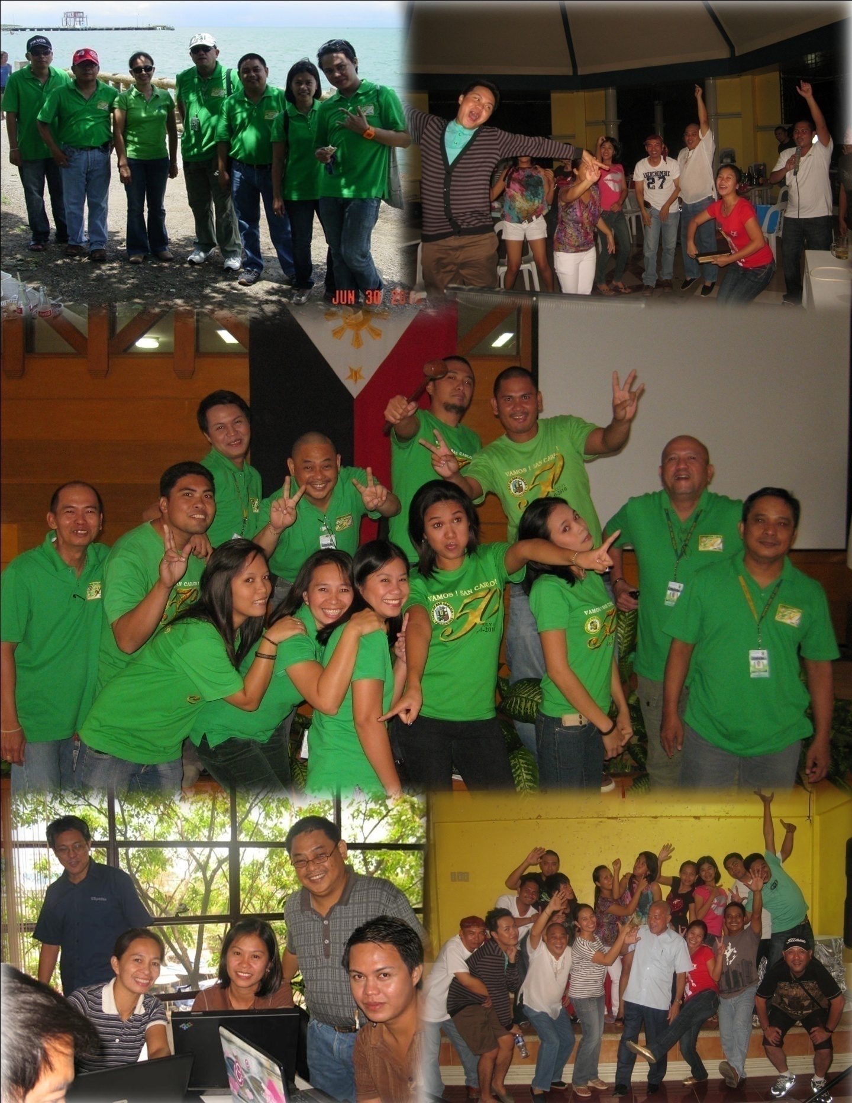

Picture **Gallery**

30

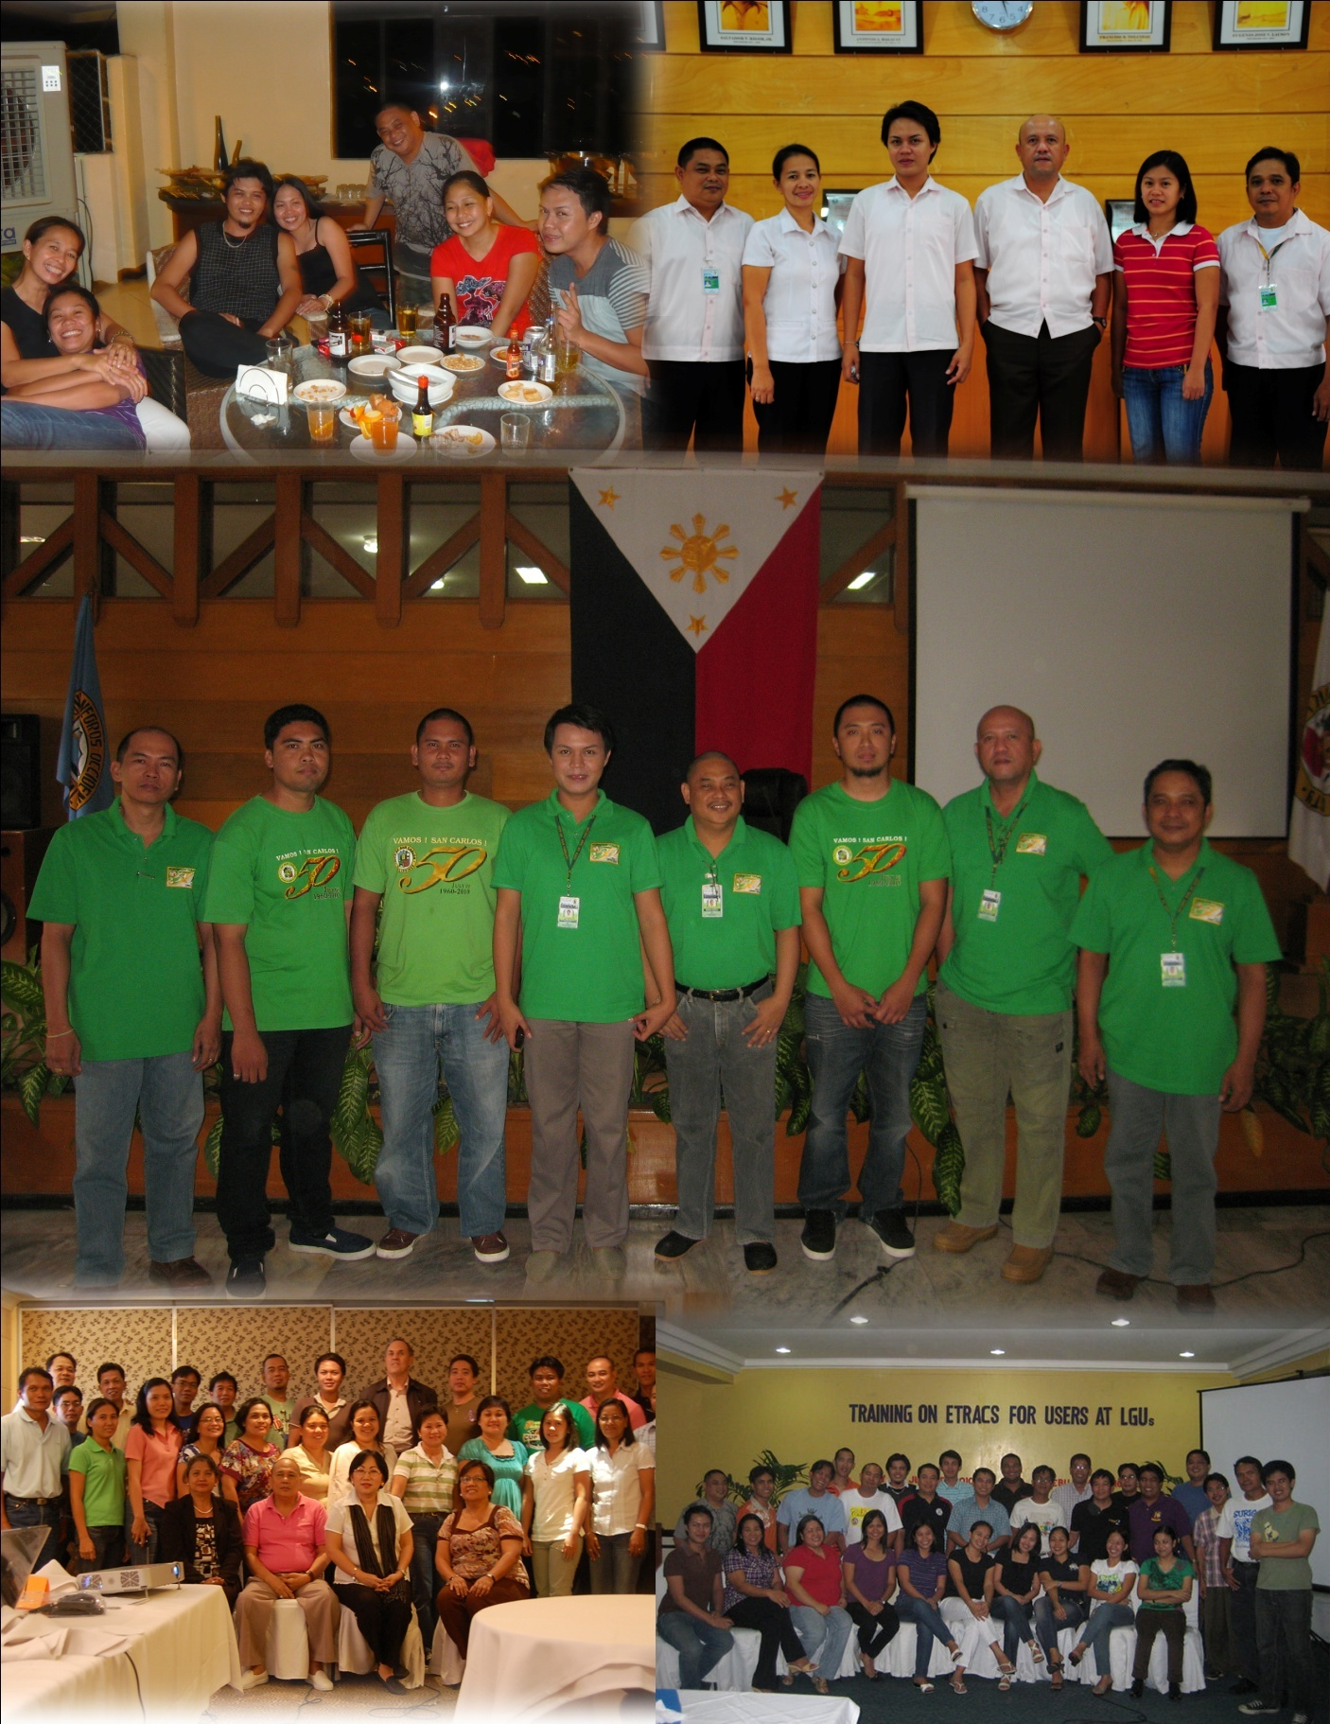

Picture **Gallery**

31

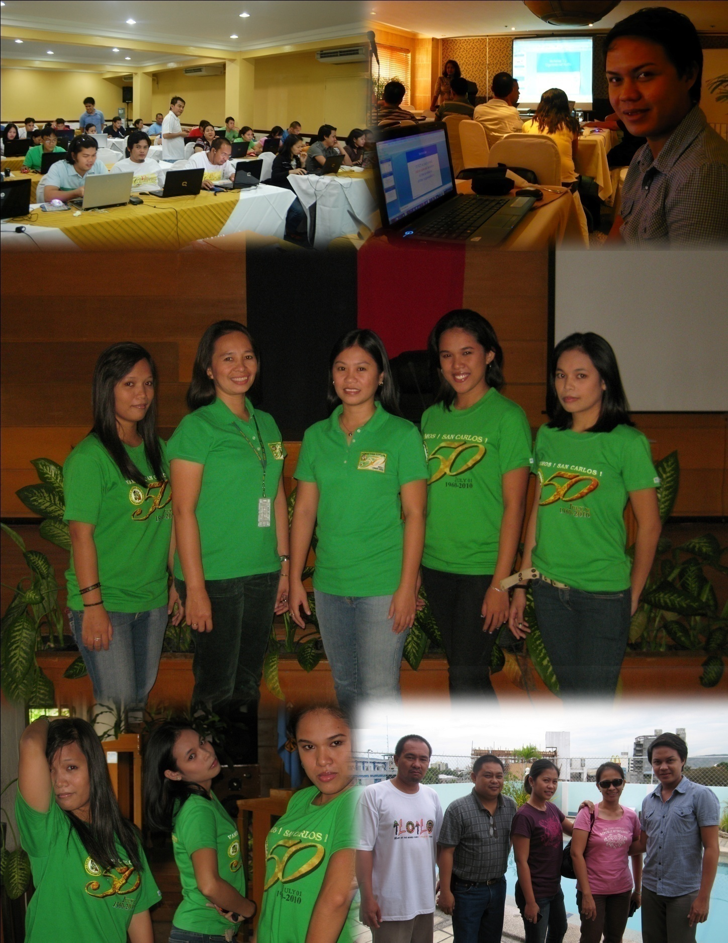

Picture **Gallery**

32